An ISO 9001 : 2008 Certified Co.



Sah anand

ALLOYS



## CARBON STEEL & ALLOY STEEL CASTING

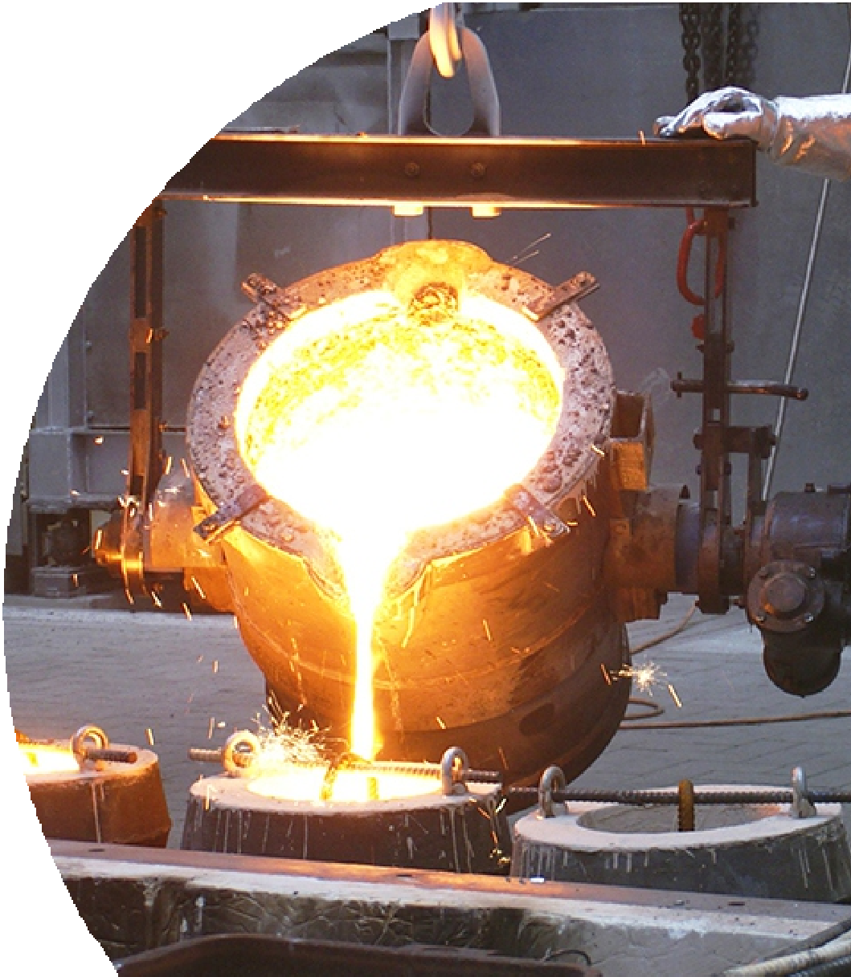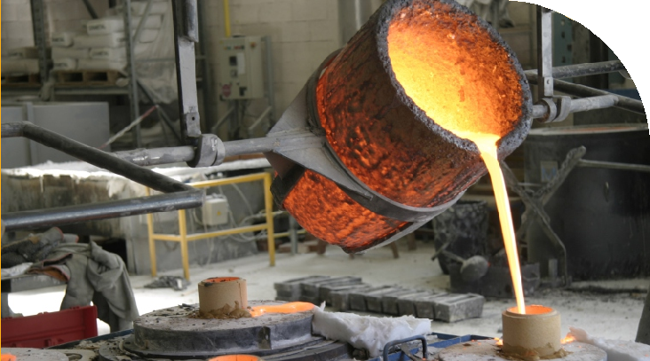

**MANUFACTURER OF ALL TYPE OF M.S. CASTING, S.G.I. CASTING AND C.I.CASTING & OTHER ALLOYS CASTING**

[*www.sahjanandalloys.com*](http://www.sahjanandalloys.com/)

We, at SAHJANAND ALLOYS are engaged in Manufacturing of a wide range of Steel casting and S.G.I. and C.I.Casting in different metallurgical speciﬁcations. These includes WCB Casting, Manganese Steel &amp; Carbon Steel Casting, Nickel and Molly based Casting, EN Series Casting etc. located at Plot No.53 & amp; 54 Saundarya Industrial Estate, Near Mizan Motor Weigh Bridge, Bakrol-Gatrad Road, Bakrol, Ahmedabad-382430, our well developed infrastructure with complete production facilities spread over an area of 1800 sq. meters. Casting foundry experience more than 15 years. Manufacture highest quality casting at very competitive rate and provide prompt delivery to all customers in India and outside India. The Company Manufactures products for customers who expect perfection. Our Casting capacity range is between 20 kg to 2500 kg single piece.

Today the company has earned a good reputation in Marine Industries, Sugar and Paper Mill Industries, Rolling Mill Industries, Mining and Mineral Industries, Crusher Machinery, Rubber Mill Industries, Irrigation Industries, Power Plant Industries, Various types of Valves and pump Casting, Coupling and Gear Boxes and All other types of Machinery parts by setting high business standards in depth engineering knowledge and experience, with a solemn commitment to maintain the highest quality standards and just in time delivery.

## OUR MAIN PRODUCTS

Grades as per National and international standards like. IS standard, ASTM standard, EN Series etc.

Plain Carbon Steel Low Alloys Steel

Corrosion Resistance Stainless Steel Heat Resistant Steel

Manganese Steel Abrasive resistant Casting

S.G.I. and C.I. Casting

All other grades as per customer’s speciﬁcation

## APPLICATION

**TYPE OF CASTING APPLICATION**

Marine Bollard Casting Rolling Mill Machinery Plants Chemical Machinery Plants Sugar Mill Machinery Parts Cement Mill Machinery Plant

Crusher Machine Machinery Parts Valves and Pump Casting

Power Plant Machinery Coupling & Gear Box Casting Irrigation Machinery Parts Other Engineering Products.

Marine Parts Rolling Mill Sugar Mill



Valve Industries Crusher

Dam Gate

Fertilizer Machinery & More Industries...

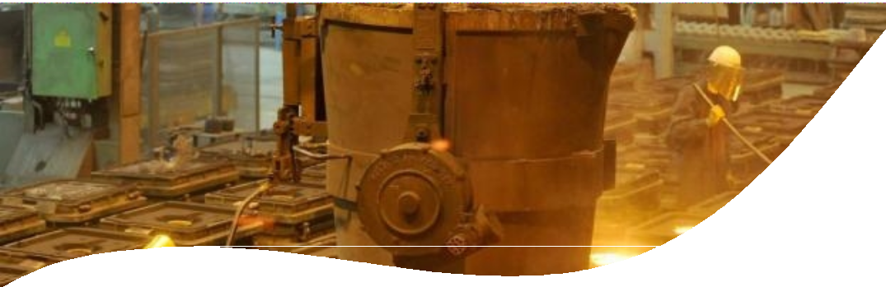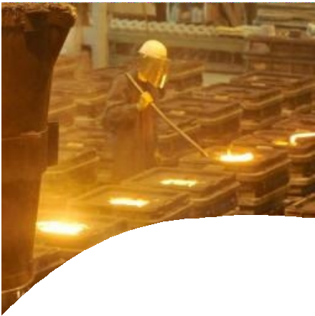

# FOUNDRY DETAILS & FACILITIES

Power Connection 625 KWA

Induction Furnace with Melting capacity is 2500 Kg, 1000Kg, 200Kg and 150Kg Crucible–Inductotherm India Pvt Ltd

Co2 & 2Part sand hand moulding Mach plate patterns

Chemical Test : Spectrometer ( Fe and Ni Base ) with 24 elements – Metal Power Analytical India Pvt Ltd

Mechanical Test : NABL Approved laboratory test certiﬁcate will be provided if required. Heat Treatment : 7 Feet x 7 Feet x 5 Feet in house furnace

Shot Blasting Machine : 6 Feet x 6 Feet x 5 Feet – double door shot blast machine in House

# INSTALL CAPACITY

Over Head Crane : 5 Ton Capacity Crane – 04 Nos Installed Capacity 300 Mt.

Present Utilized 200 Mt. Weight Range 20 kg to 2500 kg.

# CRITICAL JOBS

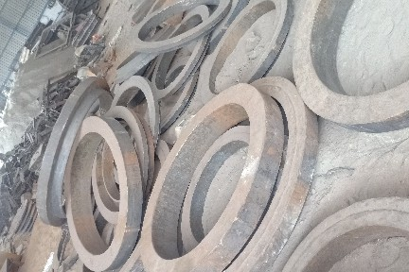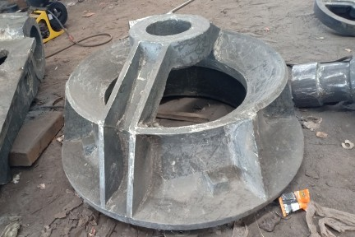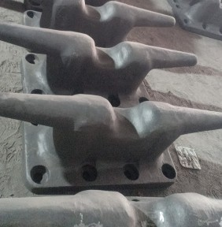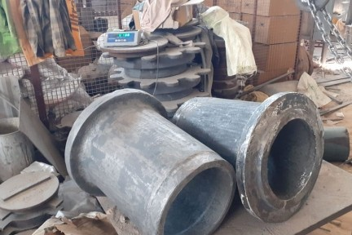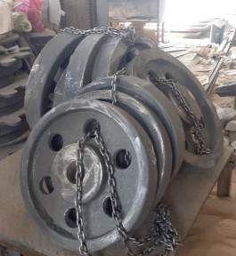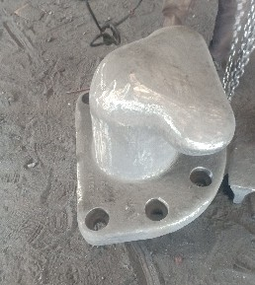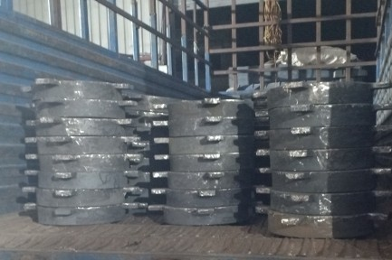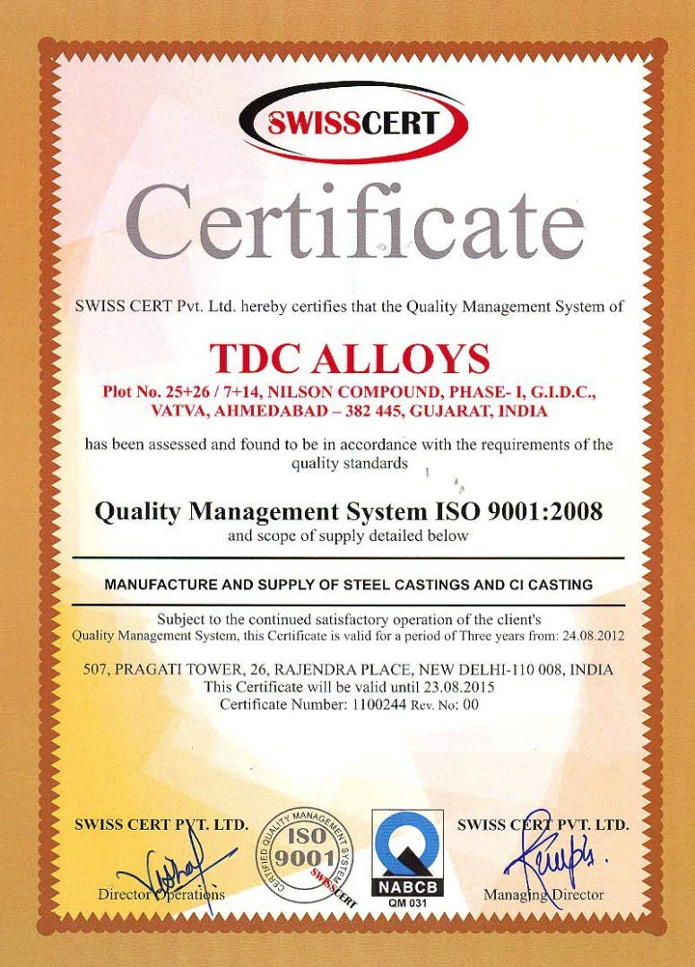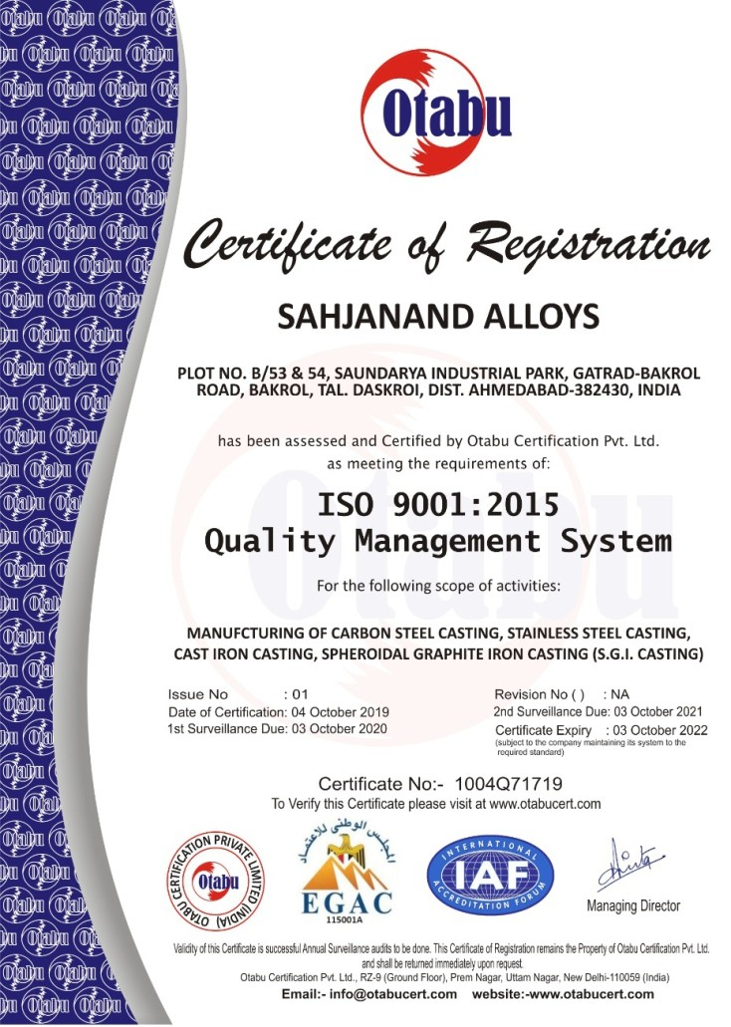

GRAPHIC POINT M.: 9586 000 888

Sah anand

ALLOYS

**CARBON STEEL & ALLOY STEEL CASTING**

**MANUFACTURER OF ALL TYPES M.S., S.G.I. AND C.I. CASTING**

Saundarya Industrial Estate, B/53 & 54 , Survey No.: 396-398-401, Bakrol-Bujrang, Ta. Daskroi, Ahmedabad-382430. (Gujarat).

Website : [www.sahjanandalloys.com](http://www.sahjanandalloys.com/) E-mail : [sahjanandalloys@gmail.com](mailto:sahjanandalloys@gmail.com)

Contact No.: Kalpesh Patel : 09099705002 Amit Brahmbhatt : 08866006571